CD Lab #8
Question 1

parser.c
/*

Design the recursive descent parser to parse array declarations and expression
statements with error reporting. Subset of grammar 7.1 is as follows:

Program -> main ( ) { Declarations Statement-List }
Declarations -> Data-Type Identifier-List ; Declarations | EP

Data-Type -> int | char

Identifier-List -> id Identifier-List-prime
Identifier-List-prime -> , Identifier-List | [ number ] Identifier-List-prime-prime | EP
Identifier-List-prime-prime -> , Identifier-List | EP

Statement-List -> Statement Statement-List | EP
Statement -> Assign-Stat | Decision_Stat | Looping_Stat;
Assign-Stat -> id = Expn

Expn -> Simple-Expn Eprime
Eprime -> Relop Simple-Expn | EP
Simple-Expn -> Term SEprime

SEprime -> Addop Term SEprime | EP
Term -> Factor Tprime
Tprime -> Mulop Factor Tprime | EP
Factor -> id | num

Decision_Stat -> if ( Expn ) { Statement_List } Dprime
Dprime -> else { Statement_List } | EP
Looping_Stat -> while ( Expn ) { Statement_List } | for ( Assign-Stat ; Expn ; Assign-Stat ) { Statement_List }

Relop -> == | != | <= | >= | > | <
Addop -> + | -
Mulop -> * | / | %

*/

#include <stdio.h>
#include <stdlib.h>
#include <string.h>
#include <ctype.h>
#include "la.h"

FILE *f;
struct token t;

void printToken(){
FILE *fd;
struct token tkn;
int numTkn=200;

fd = fopen("input.c", "r");

if (fd == NULL)
{
printf("Cannot open file\n");
exit(0);
}

int i;
for(i=0; i<=numTkn; i++){
tkn = getNextToken(fd);
if(tkn.row == -1)
exit(0);
printf("%d. <%s, %d, %d, %s>\n", i, tkn.lexeme, tkn.row, tkn.col, tkn.type);
}
}

void valid()
{
printf("Success\n\n\n=== Tokens Generated are ===\n");
printToken();
exit(0);
}

void invalid()
{
printf("at position (row : %d, col : %d)\n\n", t.row, (t.col-6));
printf("ERROR\n");
exit(0);
}

void Program(); //done
void declarations(); //done
void datatype(); //done
void id_list(); //done
void id_listPrime(); //done
void id_listPrime2(); //done
void stmt_list(); //done
void statement(); //done
void assign_stat(); //done
void expn(); //done
void eprime(); //done
void simple_expn(); //done
void seprime(); //done
void term(); //done
void tprime(); //done
void factor(); //done
void decision_stat(); //done
void dprime(); //done
void looping_stat(); //done
void relop(); //done
void addop(); //done
void mulop(); //done

void Program()
{
t = getNextToken(f);

if (strcmp(t.lexeme, "main") == 0)
{
t = getNextToken(f);

if (strcmp(t.lexeme, "(") == 0)
{
t = getNextToken(f);
if (strcmp(t.lexeme, ")") == 0)
{
t = getNextToken(f);
if (strcmp(t.lexeme, "{") == 0)
{
declarations();
stmt_list();
t = getNextToken(f);
if (strcmp(t.lexeme, "}") == 0)
{
valid();
}
else
{
printf("Expected }\n");
invalid();
}
}
else
{
printf("Expected {\n");
invalid();
}
}
else
{
printf("Expected LC\n");
invalid();
}
}
else
{
printf("Expected RC\n");
invalid();
}
}
else
{
printf("Expected main\n");
invalid();
}
}

void declarations()
{
t = getNextToken(f);
int len = strlen(t.lexeme);
if (strcmp(t.type, "identifier") == 0)
{
fseek(f, -len, SEEK_CUR);
return;
}
else if (strcmp(t.type, "RC") == 0)
{
fseek(f, -len, SEEK_CUR);
return;
}
else
fseek(f, -len, SEEK_CUR);

datatype();
id_list();
t = getNextToken(f);
numTkn++;
if (strcmp(t.lexeme, ";") == 0)
{
declarations();
return;
}
else if (strcmp(t.type, "identifier") == 0)
{
fseek(f, -1, SEEK_CUR);
return;
}
else
{
printf("Expected ; or identifier\n");
invalid();
}
}

void datatype()
{
t = getNextToken(f);
if (strcmp(t.type, "keyword") == 0)
return;
else
{
printf("Expected int or char\n");
invalid();
}
}

void id_list()
{
t = getNextToken(f);
if (strcmp(t.type, "identifier") == 0)
{
id_listPrime();
return;
}
else
{
printf("Expected identifier\n");
invalid();
}
}

void id_listPrime()
{
t = getNextToken(f);
int len = strlen(t.lexeme);
if (strcmp(t.lexeme, ";") == 0)
{
fseek(f, -len, SEEK_CUR);
return;
}
else
fseek(f, -len, SEEK_CUR);

t = getNextToken(f);
if (strcmp(t.lexeme, ",") == 0)
{
id_list();
return;
}
else if (strcmp(t.lexeme, "[") == 0)
{
t = getNextToken(f);

if (strcmp(t.type, "number") == 0)
{
t = getNextToken(f);

if (strcmp(t.lexeme, "]") == 0)
{
id_listPrime2();
return;
}
else
{
printf("Expected ]\n");
invalid();
}
}
else
{
printf("Expected number\n");
invalid();
}
}
else
{
printf("Expected , or [\n");
invalid();
}
}

void id_listPrime2()
{
t = getNextToken(f);
int len = strlen(t.lexeme);
if (strcmp(t.lexeme, ";") == 0)
{
fseek(f, -len, SEEK_CUR);
return;
}
else
fseek(f, -len, SEEK_CUR);

t = getNextToken(f);
if (strcmp(t.lexeme, ",") == 0)
{
id_list();
return;
}
else
{
printf("Expected ,\n");
invalid();
}
}

void stmt_list()
{
t = getNextToken(f);
int len = strlen(t.lexeme);
if (strcmp(t.type, "RC") == 0)
{
fseek(f, -len, SEEK_CUR);
return;
}
else
fseek(f, -len, SEEK_CUR);

statement();
stmt_list();
return;
}

void statement()
{
t = getNextToken(f);
int len = strlen(t.lexeme);
if (strcmp(t.lexeme, "if") == 0)
{
fseek(f, -len, SEEK_CUR);
decision_stat();
return;
}
else if (strcmp(t.lexeme, "while") == 0)
{
fseek(f, -len, SEEK_CUR);
looping_stat();
return;
}
else if (strcmp(t.lexeme, "for") == 0)
{
fseek(f, -len, SEEK_CUR);
looping_stat();
return;
}
else
{
fseek(f, -len, SEEK_CUR);
assign_stat();
t = getNextToken(f);

if (strcmp(t.lexeme, ";") == 0)
return;
else
{
printf("Expected ;\n");
invalid();
}
}
}

void assign_stat()
{
t = getNextToken(f);
if (strcmp(t.type, "identifier") == 0)
{
t = getNextToken(f);

if (strcmp(t.lexeme, "=") == 0)
{
expn();
return;
}
else
{
printf("Expected =\n");
invalid();
}
}
else
{
printf("Expected identifier\n");
invalid();
}
}

void expn()
{
simple_expn();
eprime();
return;
}

void eprime()
{
t = getNextToken(f);
int len = strlen(t.lexeme);
if (strcmp(t.lexeme, ";") == 0)
{
fseek(f, -len, SEEK_CUR);
return;
}
else if (strcmp(t.lexeme, ")") == 0)
{
fseek(f, -len, SEEK_CUR);
return;
}
else
fseek(f, -len, SEEK_CUR);

relop();
simple_expn();
return;
}

void simple_expn()
{
term();
seprime();
return;
}

void seprime()
{
t = getNextToken(f);
int len = strlen(t.lexeme);
if (strcmp(t.lexeme, ";") == 0)
{
fseek(f, -len, SEEK_CUR);
return;
}
else if (strcmp(t.lexeme, "==") == 0)
{
fseek(f, -len, SEEK_CUR);
return;
}
else if (strcmp(t.lexeme, "!=") == 0)
{
fseek(f, -len, SEEK_CUR);
return;
}
else if (strcmp(t.lexeme, "<=") == 0)
{
fseek(f, -len, SEEK_CUR);
return;
}
else if (strcmp(t.lexeme, ">=") == 0)
{
fseek(f, -len, SEEK_CUR);
return;
}
else if (strcmp(t.lexeme, "<") == 0)
{
fseek(f, -len, SEEK_CUR);
return;
}
else if (strcmp(t.lexeme, ">") == 0)
{
fseek(f, -len, SEEK_CUR);
return;
}
else if (strcmp(t.lexeme, ")") == 0)
{
fseek(f, -len, SEEK_CUR);
return;
}
else
fseek(f, -len, SEEK_CUR);

addop();
term();
seprime();
return;
}

void term()
{
factor();
tprime();
return;
}

void tprime()
{
t = getNextToken(f);
int len = strlen(t.lexeme);
if (strcmp(t.lexeme, ";") == 0)
{
fseek(f, -len, SEEK_CUR);
return;
}
else if (strcmp(t.lexeme, "==") == 0)
{
fseek(f, -len, SEEK_CUR);
return;
}
else if (strcmp(t.lexeme, "!=") == 0)
{
fseek(f, -len, SEEK_CUR);
return;
}
else if (strcmp(t.lexeme, "<=") == 0)
{
fseek(f, -len, SEEK_CUR);
return;
}
else if (strcmp(t.lexeme, ">=") == 0)
{
fseek(f, -len, SEEK_CUR);
return;
}
else if (strcmp(t.lexeme, ">") == 0)
{
fseek(f, -len, SEEK_CUR);
return;
}
else if (strcmp(t.lexeme, "<") == 0)
{
fseek(f, -len, SEEK_CUR);
return;
}
else if (strcmp(t.lexeme, "+") == 0)
{
fseek(f, -len, SEEK_CUR);
return;
}
else if (strcmp(t.lexeme, "-") == 0)
{
fseek(f, -len, SEEK_CUR);
return;
}
else if (strcmp(t.lexeme, ")") == 0)
{
fseek(f, -len, SEEK_CUR);
return;
}
else
fseek(f, -len, SEEK_CUR);

mulop();
factor();
tprime();
return;
}

void factor()
{
t = getNextToken(f);
if (strcmp(t.type, "identifier") == 0)
return;
else if (strcmp(t.type, "number") == 0)
return;
else
{
printf("Expected identifier or number\n");
invalid();
}
}

void decision_stat()
{
t = getNextToken(f);
if (strcmp(t.lexeme, "if") == 0)
{
t = getNextToken(f);

if (strcmp(t.lexeme, "(") == 0)
{
expn();
t = getNextToken(f);

if (strcmp(t.lexeme, ")") == 0)
{
t = getNextToken(f);

if (strcmp(t.lexeme, "{") == 0)
{
stmt_list();
t = getNextToken(f);

if (strcmp(t.lexeme, "}") == 0)
{
dprime();
return;
}
else
{
printf("Expected }\n");
invalid();
}
}
else
{
printf("Expected {\n");
invalid();
}
}
else
{
printf("Expected )\n");
invalid();
}
}
else
{
printf("Expected (\n");
invalid();
}
}
else
{
printf("Expected if\n");
invalid();
}
}

void dprime()
{
//follow remaining
t = getNextToken(f);
if (strcmp(t.lexeme, "else") == 0)
{
t = getNextToken(f);

if (strcmp(t.lexeme, "{") == 0)
{
stmt_list();
t = getNextToken(f);

if (strcmp(t.lexeme, "}") == 0)
return;
else
{
printf("Expected }\n");
invalid();
}
}
else
{
printf("Expected {\n");
invalid();
}
}
else
{
printf("Expected else\n");
invalid();
}
}

void looping_stat()
{
t = getNextToken(f);
if (strcmp(t.lexeme, "while") == 0)
{
t = getNextToken(f);

if (strcmp(t.lexeme, "(") == 0)
{
expn();
t = getNextToken(f);

if (strcmp(t.lexeme, ")") == 0)
{
t = getNextToken(f);

if (strcmp(t.lexeme, "{") == 0)
{
stmt_list();
t = getNextToken(f);

if (strcmp(t.lexeme, "}") == 0)
return;
else
{
printf("Expected }\n");
invalid();
}
}
else
{
printf("Expected {\n");
invalid();
}
}
else
{
printf("Expected )\n");
invalid();
}
}
else
{
printf("Expected (\n");
invalid();
}
}
else if (strcmp(t.lexeme, "for") == 0)
{
t = getNextToken(f);\

if (strcmp(t.lexeme, "(") == 0)
{
assign_stat();

t = getNextToken(f);
if (strcmp(t.lexeme, ";") == 0)
{
expn();
t = getNextToken(f);

if (strcmp(t.lexeme, ";") == 0)
{
assign_stat();
t = getNextToken(f);

if (strcmp(t.lexeme, ")") == 0)
{
t = getNextToken(f);

if (strcmp(t.lexeme, "{") == 0)
{
stmt_list();
t = getNextToken(f);

if (strcmp(t.lexeme, "}") == 0)
return;
else
{
printf("Expected }\n");
invalid();
}
}
else
{
printf("Expected {\n");
invalid();
}
}
else
{
printf("Expected )\n");
invalid();
}
}
else
{
printf("Expected ;\n");
invalid();
}
}
else
{
printf("Expected ;\n");
invalid();
}
}
else
{
printf("Expected (\n");
invalid();
}
}
else
{
printf("Expected while or for\n");
invalid();
}
}

void relop()
{
t = getNextToken(f);
if (strcmp(t.lexeme, "==") == 0)
return;
else if (strcmp(t.lexeme, "!=") == 0)
return;
else if (strcmp(t.lexeme, "<") == 0)
return;
else if (strcmp(t.lexeme, ">") == 0)
return;
else if (strcmp(t.lexeme, "<=") == 0)
return;
else if (strcmp(t.lexeme, ">=") == 0)
return;
else
{
printf("Expected relop\n");
invalid();
}
}

void addop()
{
t = getNextToken(f);
if (strcmp(t.lexeme, "+") == 0)
return;
else if (strcmp(t.lexeme, "-") == 0)
return;
else
{
printf("Expected + or -\n");
invalid();
}
}

void mulop()
{
t = getNextToken(f);
if (strcmp(t.lexeme, "*") == 0)
return;
else if (strcmp(t.lexeme, "/") == 0)
return;
else if (strcmp(t.lexeme, "%") == 0)
return;
else
{
printf("Expected *, / or %%\n");
invalid();
}
}

int main()
{
f = fopen("input.c", "r");

if (f == NULL)
{
printf("Cannot open file\n");
exit(0);
}

Program();
}

------------------------------------------------------------------------------------------------------------------------

sample.c (correct)

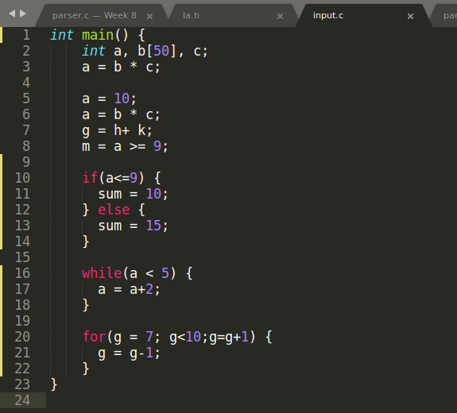

OUTPUT :
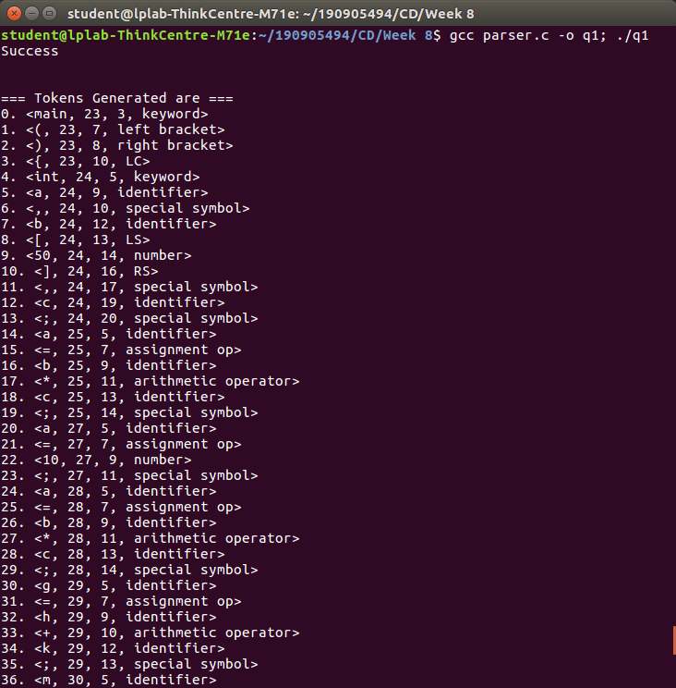

sample.c (incorrect) with ‘=’ missing

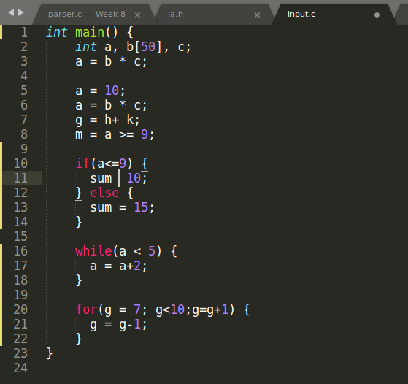

OUTPUT :

